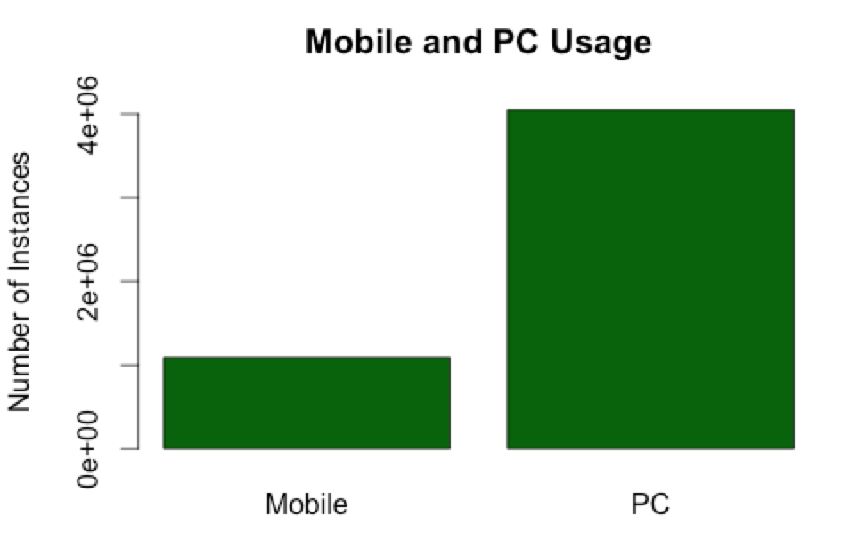

mobile: 1091121 rows

PC: 4048741 rows